Financial Performance Insights: A Power BI Analysis

Amareshwari Vadlakonda

Introduction & Data Overview

Data Source and Preparation

The data for this analysis is sourced from the standard Microsoft 'Financial Sample.xlsx' spreadsheet. In Power BI Desktop, I loaded the data directly from the Excel file.

Basic data type validation was performed, and Power BI's automatic relationship detection was utilized, making the dataset ready for visualization.

For our profitability analysis, I created a custom Profit measure calculated as Gross Sales - COGS

Identifying Trends Across Time

Sales, Profit, and Cost Trends Over Time

**Objective:** "Identify trends across time and what these show us.

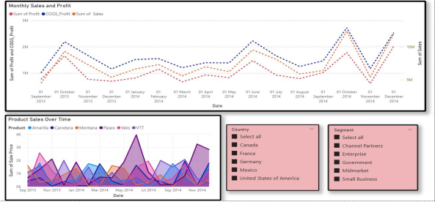

Identifying Trends Across Time

Sales, Profit, and Cost Trends Over Time

Looking at the **'Monthly Sales and Profit'** line chart, which now includes 'Sum of COGS_Profit', we can observe clear seasonal trends across sales, profit, and the cost of goods sold."

"Both 'Sum of Sales' and 'Sum of Profit' typically show a consistent build-up through the year, peaking significantly around October-November, followed by a noticeable dip in December. This strongly suggests a recurring year-end sales cycle, likely influenced by holiday purchasing or fiscal year-end activities."

"The 'Sum of COGS_Profit' line (representing Cost of Goods Sold) closely mirrors the cyclical pattern of sales and profit. This is an expected and positive indicator, as it suggests that costs are well-managed and scale proportionally with sales volume."

"The consistent *gap* between 'Sum of Sales' and 'Sum of COGS_Profit', and subsequently the 'Sum of Profit' line, implies that the gross profit margin remains relatively stable across these fluctuations, reinforcing efficient cost control."

"The **'Product Sales Over Time'** area chart provides a deeper look into individual product contributions to these overall trends. We can see that 'Montana' and 'Paseo' consistently maintain strong sales contributions across all months, serving as the core revenue drivers."

"Conversely, products such as 'Amarilla' and 'VTT' exhibit more variability and generally lower overall sales contribution."

Products Receiving the Most Discounts

Discount Analysis by Product

From the **'Total Discounts given per Product'** bar chart, it's immediately apparent that 'Montana' and 'Paseo' have received the highest total discount amounts across the dataset."

However, when we cross-reference this with the accompanying table, we observe that 'Montana' and 'Paseo' also lead in 'Sum of Units Sold' and 'Sum of Profit'.

This suggests that the high *total* discount for these products is primarily a consequence of their high sales volume. It indicates a strategy of applying many smaller discounts across a large number of units, rather than deep individual price cuts.

In contrast, products like 'VTT', while having lower overall sales, show a comparatively high 'Average of Discounts' (12,773.08 compared to Montana's 12,462.70). This pattern implies that 'VTT' might be subjected to larger *individual* discounts, likely as a tactical move to clear inventory or stimulate sales for slower-moving items.

The **'Sum of Discounts and Sum of Units Sold by Product'** chart visually reinforces this correlation, showing that products with the highest units sold also tend to accumulate the largest total discounts.

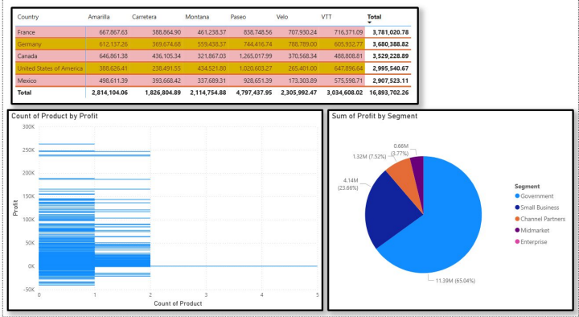

Recommendations to Increase Revenue

**Content:**

● **Recommendation 1: Capitalize on High-Profit Segments.**

From the **'Sum of Profit by Segment'** pie chart, we clearly see that 'Government' is the largest contributor to overall profit (53.94%), followed by 'Small Business' (17.77%).

"**Why:** Focusing sales and marketing efforts more intensely on these highly profitable segments offers a high-return strategy. Leveraging existing success and established relationships in these areas can lead to efficient revenue increases with potentially lower customer acquisition costs."

● **Recommendation 2: Optimize Product-Specific Strategies.**

"Referring back to our trend and discount analysis (from previous slides), 'Montana' and 'Paseo' are consistently strong performers that receive significant total discounts.

Recommendations to Increase Revenue

**Content:**

**Why:** Implement targeted promotional campaigns for these top-selling products during their peak seasons (e.g., Q4) to further maximize their already strong demand and capitalize on existing customer loyalty. For products like 'VTT', which exhibit high average discounts but lower sales volume, it's crucial to re-evaluate their pricing strategy or consider product repositioning/diversification to ensure resources are allocated to truly revenue-generating lines.

● **Recommendation 3: Expand on Strong Regional Performance.**

The cross-tab table showing sales by 'Country' and 'Product' indicates that countries like 'United States of America' and 'Canada' generate very high total sales."

**Why:** Explore opportunities for deeper market penetration within these high-performing countries or strategic expansion into similar demographic/economic regions. By replicating successful sales and marketing strategies from these established markets, the company can achieve efficient and lower-risk revenue growth by leveraging existing insights and brand recognition.

**Conclusion**

In summary, our Power BI analysis of the financial sample data has enabled us to effectively address the key business questions by:"

● "Identifying clear seasonal sales, profit, and cost trends, highlighting peak performance periods."

● "Understanding the strategic application of discounts across different products, distinguishing between volume-driven and targeted promotions."

● "Formulating actionable recommendations for revenue growth by focusing on high-profit segments, optimizing product-specific strategies, and leveraging strong regional performance."

"Power BI proves to be an invaluable tool for transforming raw data into clear, actionable business intelligence, empowering data-driven decision-making."

Thank you for your time

Amareshwari Vadlakoonda